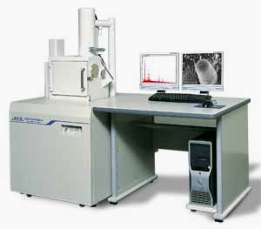
Capabilities – JSM-6490-LV
W filament with super conical lens optics
Enhanced SE imaging
3.0nm @ 30kV
8.0nm @ 3kV
15 nm @ 1kV
Low Vacuum 4.0nm
Standard automated features
Auto Focus/Auto Stigmator, Auto Gun, and Auto Contrast and Brightness
Large specimen chamber
Asynchronous five-axis mechanically eucentric stage with comp-eucentric rotation and tilt
Multiple live image display
Signal mixing
Video capability (.avi files)

